## **Workshop Assignment for Enterprise Architects: Value Chain Analysis & Modeling**

### **🎯 Objective:**

To understand and apply Porter’s Value Chain framework within your industry, identify key areas of cost optimization and differentiation, and design a future-ready, technology-enabled value chain.

## **📘 Assignment Instructions:**

You are an Enterprise Architect working for an organization undergoing digital transformation. Your goal is to:

1. Analyze your company’s current value chain.
2. Identify gaps and inefficiencies.
3. Use Porter’s framework (Primary and Support Activities) to evaluate value creation.
4. Propose a **Digitally Optimized Value Chain**.
5. Highlight how emerging technologies (AI, RPA, Data Cloud, IoT, CRM, etc.) can automate or enhance key activities.
6. Present a diagram + written summary (choose one industry).

### **📁 Deliverables:**

1. Value Chain Model (Current State)
2. Value Chain Analysis (Gap Identification)
3. Target State Value Chain (Optimized with technology)
4. Strategic Recommendations (cost or differentiation)
5. Diagram with labeled activities
6. Written justification for each change

## **🏭 Solution Example – Manufacturing Industry (Smart Factory)**

### **📌 1. Primary Activities:**

| **Activity** | **Current State** | **Optimized State** |
| --- | --- | --- |
| Inbound Logistics | Manual scheduling | AI predicts demand, just-in-time deliveries |
| Operations | Reactive maintenance | IoT + Predictive Maintenance |
| Outbound Logistics | Delays in shipping | RPA automates carrier selection and tracking |
| Marketing & Sales | Generic campaigns | CRM + AI for hyper-personalized B2B selling |
| Services | Technicians dispatched late | Field Service Lightning schedules real-time support |

### **📌 2. Support Activities:**

| **Activity** | **Current State** | **Optimized State** |
| --- | --- | --- |
| Procurement | Supplier delays | Blockchain for supplier traceability |
| HR Management | Skill mismatches | AI-based workforce planning |
| Technology | Legacy MES | Cloud-first ERP + MES integration |
| Infrastructure | Paper-based ops | Unified Data Cloud + MuleSoft integration layer |

### **📈 Strategic Outcome:**

* Cost reduced via IoT + Predictive Maintenance
* Differentiation through custom production for B2B clients

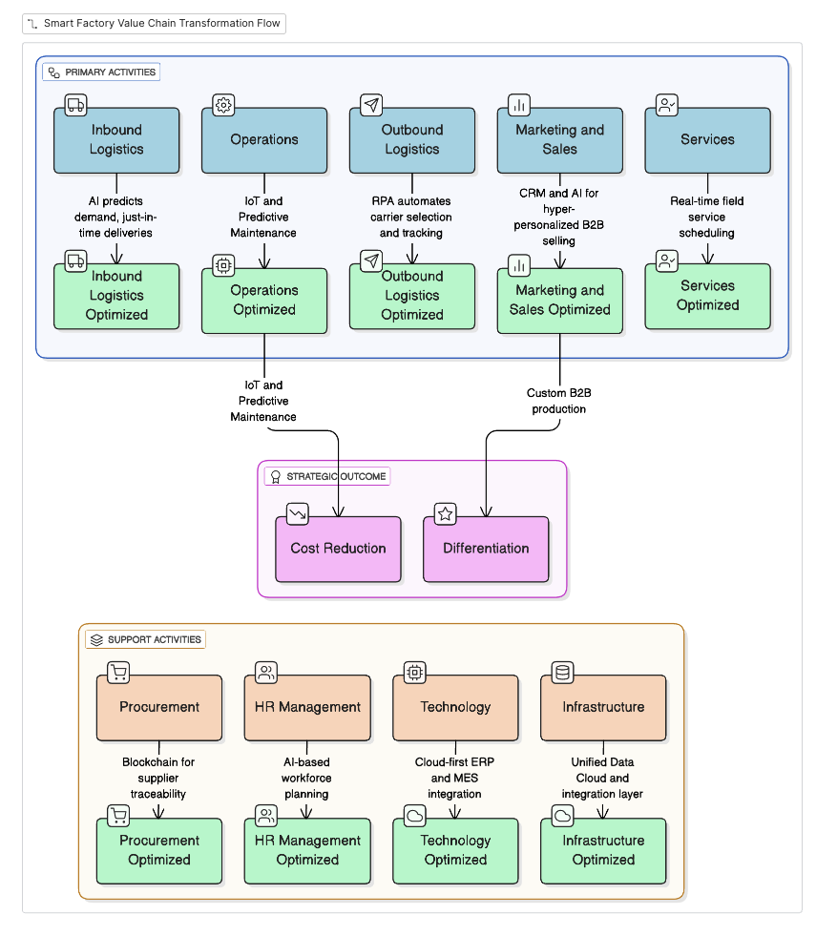

## **💊 Solution Example – Pharma Industry (Drug Lifecycle Management)**

### **📌 1. Primary Activities:**

| **Activity** | **Current State** | **Optimized State** |
| --- | --- | --- |
| Inbound Logistics | Delays from global suppliers | AI risk scoring + smart contracts |
| Operations | Long R&D cycles | Digital twins for molecule simulation |
| Outbound Logistics | Cold chain failures | IoT tracking sensors for temperature control |
| Marketing & Sales | One-size-fits-all reps | CRM + AI for HCP (healthcare provider) targeting |
| Services | No post-launch monitoring | Patient app for adverse effect logging (RWE) |

### **📌 2. Support Activities:**

| **Activity** | **Current State** | **Optimized State** |
| --- | --- | --- |
| Procurement | Expensive CROs | AI evaluates CRO/vendor efficiency |
| HR | Manual staffing | GxP-trained talent matching via AI |
| Technology | Disparate systems | Unified GxP-compliant platform |
| Infrastructure | Compliance-heavy | Audit trails via Blockchain |

### **📈 Strategic Outcome:**

* Differentiation: Safer drugs, faster to market
* Cost: Reduced R&D trial overhead

## **🏦 Solution Example – Banking Industry (Retail Lending)**

### **📌 1. Primary Activities:**

| **Activity** | **Current State** | **Optimized State** |
| --- | --- | --- |
| Inbound Logistics | Manual customer onboarding | OCR + eKYC + facial biometrics |
| Operations | High NPL (non-performing loans) | AI risk scoring, dynamic credit limits |
| Outbound Logistics | Paper checks | Digital disbursements (mobile, crypto rails) |
| Marketing & Sales | Branch campaigns | Digital journey orchestration via CRM |
| Services | Long call wait times | Agentforce + self-service bots for account support |

### **📌 2. Support Activities:**

| **Activity** | **Current State** | **Optimized State** |
| --- | --- | --- |
| Procurement | Vendor lock-in | Cloud marketplaces with AI-based selection |
| HR | Retention issues | Skills cloud + AI engagement nudges |
| Technology | Monolithic core | Microservices + API-first banking |
| Infrastructure | Fragmented | Real-time integration layer (Data Fabric) |

### **📈 Strategic Outcome:**

* Differentiation: Customer self-service & personalization
* Cost: Reduced operational overhead from automation

## **🛠 Bonus Activities:**

* Use Lucidchart or PowerPoint to sketch your industry’s value chain.
* Write 1-page justification for each change to stakeholders.
* Propose KPIs: Cost per activity, cycle time, CSAT, NPS, error rate.